**AMERICAN INTERNATIONAL UNIVERSITY–BANGLADESH (AIUB)**

**Dept. of Computer Science**

**Faculty of Science and Technology**

**CSC2210: OBJECT ORIENTED PROGRAMMING 2**

**Summer 2024-2025**

**Section: [edit here]**

**Group No: 0912**

**Project Report On**

***Project name [ Farm Invoice Manager]***

**Supervised By**

**Md. Hasibul Hasan**

**Submitted By: MAHMMOD, MD. SHAFI**

|  |  |
| --- | --- |
| Name | ID |
| **TASNIM, JARIN** | **23-50749-1** |
| **MAHMMOD, MD. SHAFI** | **23-54122-3** |
| **RISHAD, NAJIAT ISLAM** | **23-55218-3** |

|  |  |  |  |  |  |  |  |
| --- | --- | --- | --- | --- | --- | --- | --- |
| **Obtained Marks for CO2 and CO3 (Description given in the following page)** | | | | | | | |
| **Assessment Criteria** | **Not Attended/ Incorrect (0)** | | **Inadequate  (1-2)** | | **Average (3)** | **Good  (4)** | **Excellent (5)** |
| **Evaluation Criteria (CO2)** | | **Total =** | | **Evaluation Criteria (CO3)** | | | **Total =** |
| Requirement fulfillment | |  | | Organization of the application | | |  |
| Validation | |  | | Representation and Integration of Database | | |  |
| Verification | |  | | Graphical User Interface | | |  |

|  |  |  |  |  |  |  |  |  |  |
| --- | --- | --- | --- | --- | --- | --- | --- | --- | --- |
| **CO2:** Display and verify the mean of a real-life Project using the concepts of C# Graphical User Interface based environment with database integration to depict a desktop-based application. | | | | | | | | | |
| **Assessment** **Criteria** | **Not Attended/ Incorrect (0)** | **Inadequate**  **(1-2)** | | **Average** **(3)** | | **Good**  **(4)** | | **Excellent** **(5)** | |
| **Evaluation Criteria** | **Evaluation Definition** | | | | | | | | |
| Requirement fulfillment | Fails to demonstrate any understanding of real-life scenario-based project development or functional requirement identification. There is no attempt to depict a project or identify functional requirements accurately. | | Demonstrates limited understanding of real-life scenario-based project development and functional requirement identification. The project depicted lacks coherence or relevance to real-life scenarios, and functional requirements are inaccurately identified or insufficiently described. | | Presents a basic depiction of a real-life scenario-based project and identifies some functional requirements. However, the project lacks depth or complexity, and some functional requirements may be vaguely defined or missing key details. | | Effectively demonstrates a realistic scenario-based project and accurately identifies most functional requirements. The project is well-developed with appropriate complexity, and functional requirements are clearly articulated with relevant details. | | Exhibits an exceptional understanding of real-life scenario-based project development and accurately identifies all functional requirements. The project is meticulously developed with thorough attention to detail, reflecting a comprehensive understanding of Object-Oriented Programming project development activities. |
| Validation | Fails to demonstrate any understanding or implementation of validation forms in their system. There is no attempt to deal with data validation, and validation requirements are completely ignored or incorrectly applied. | | Demonstrates limited understanding of validation forms and data validation techniques. While some attempt may be made to implement validation, it is incomplete or poorly executed, leading to inadequate handling of data validation. | | Shows a basic understanding of validation forms and data validation techniques. They attempt to implement validation, but some aspects may be missing or incorrectly implemented, resulting in partial or inconsistent handling of data validation. | | Effectively demonstrates the use of validation forms and implements data validation techniques. Validation is mostly accurate and comprehensive, ensuring the proper handling of data input and verification in the system. | | Exhibits an exceptional understanding and implementation of validation forms and data validation techniques. Validation is meticulously implemented with thorough attention to detail, ensuring robust data validation procedures and contributing to the overall reliability and integrity of the system. |
| Verification | Fails to demonstrate any attempt to verify the system data or functional requirements. There is no evidence of understanding or implementation of verification processes, and data flow is not considered. | | Demonstrates limited understanding of verification processes and data flow in the system. Verification attempts are incomplete or inaccurate, and there is insufficient consideration given to ensuring data integrity and functionality. | | Shows a basic understanding of verification processes and attempts to verify system data. However, verification efforts may be inconsistent or lack thoroughness, and there may be gaps in ensuring proper functional requirements and data flow. | | Identifies and verifies system data, ensuring proper functional requirements are met. Verification efforts are mostly accurate and thorough, with attention to ensuring data integrity and appropriate data flow within the system. | | Exhibits an exceptional understanding of verification processes and meticulously verifies system data. Verification efforts are comprehensive and precise, with a keen focus on ensuring all functional requirements are met and maintaining proper data flow throughout the system. |

|  |  |  |  |  |  |  |  |  |  |
| --- | --- | --- | --- | --- | --- | --- | --- | --- | --- |
| **CO3:** Prepare and Explain a real life desktop based application synthesizing several component of C# along with development tools to adhere the given requirements. | | | | | | | | | |
| **Assessment Criteria** | **Not Attended/ Incorrect (0)** | **Inadequate  (1-2)** | | **Average (3)** | | **Good  (4)** | | **Excellent (5)** | |
| **Evaluation Criteria** | **Evaluation Definition** | | | | | | | | |
| Organization of the application | Fails to identify any suitable real time application or requirements for project development activities related to OOP. | | Limited understanding about the project scopes and scenarios or identification of functional requirements. | | Lacks depth or relevance to OOP project development activities and may contain inaccuracies. Real-life scenarios are mentioned, but the discussion lacks depth or clarity. | | Consider and integrate the idea of several core aspects of the project along with relevance to real-life scenarios. Demonstrating a solid understanding of the application presentation. | | Generalize and exhibits an exceptional understanding of project preparation according to a to real-life scenarios. Also contains proper and insightful identification of the system which is comprehensive and precise. |
| Representation and Integration of Database | Fails to identify and present any understanding or implementation of database. Also failed to integrate the data with the project itself. | | Limited understanding of the database concepts or their proper way of using in a real time project. While some attempt may be made to implement but it is incomplete or poorly executed, leading to inadequate design. | | Lacks depth or relevance to database integration with the application. Shows a basic understanding but some aspects may be missing or incorrectly implemented, resulting in partial or inconsistency. May lack proper normalization. | | Integrate the database with the forms properly and implements it with proper validation which is mostly accurate and comprehensive, ensuring the proper handling of data input and verification along with general normalization. | | Exhibits an exceptional understanding and implementation of database ensuring attention to detail, and robust data manipulation procedures and contributing to the overall clarity. |
| Graphical User Interface | Fails to present or prepare GUI based application interfaces. There is no evidence of creating or integrating such things according to their usefulness. | | Limited understanding of graphical user interfaces. Lack of design knowledge. Very poor attempt to make such things which are currently obsolete or can’t be identified as coherent. | | Shows a basic understanding of creating user interfaces. Most of them are interconnected but maybe some of them lack it. However, most of it can be described as user friendly. | | Effectively identifies and meet the consider the simplicity. Design related works are mostly accurate and taken proper attention to ensuring a user-friendly coherent system. | | Exhibits an exceptional work design following a high standard of simple and elegant work. Several controls and mechanism has been organized in a preferred way according to the coherent usage . |

**Table of Contents:** **Pag no**

1. Chapter: 01 (Introduction)----------------------------------------------------------------------- 05

2. Chapter: 02 (User Story)------------------------------------------------------------------------- 05

3. Chapter: 03a (ER Diagram)---------------------------------------------------------------------- 06

4. Chapter: 03b (SQL Queries)--------------------------------------------------------------------- 07

5. Chapter: 04 (Screenshots)------------------------------------------------------------------------ 08

**Chapter 01: Introduction**

The **Farm Invoice Manager – Billing Management System** is a desktop-based application developed using **C# Windows Forms** and **SQL Server** to efficiently manage billing, sales, products, customers, and users in a farm-based business environment. The primary goal of this system is to simplify and automate the manual invoice and sales management process, reducing errors and improving productivity.This system provides a **secure login mechanism** with role-based access for **Admin and Employee**, ensuring proper data security and controlled access. Admin users can manage products, users, customers, memberships, and generate sales reports, while employees can perform sales operations and view necessary information based on their permissions.The application supports complete **product management**, **customer management**, **invoice generation**, **sales reporting**, and **printable invoices**. Features such as **password recovery**, **username and password reset**, **premium membership handling**, **date-wise sales reports**, and **graphical sales analysis** enhance usability and decision-making.With a user-friendly interface and structured data handling, the Farm Invoice Manager helps farm businesses maintain accurate records, track inventory, manage customers, and generate reliable financial reports. Overall, this project demonstrates effective use of object-oriented programming, database connectivity, and real-world business logic implementation in a desktop application.

**Chapter 02: User Story**

The **Farm Invoice Manager – Billing Management System** is designed with two essential user roles in mind: **Admin** and **Employee**. Each role has specific responsibilities and access permissions to ensure smooth, secure, and efficient management of farm billing and sales operations. Below is a brief overview of how each user interacts with the system.

### ****As an Admin****

* Log in securely to the admin dashboard using valid credentials.
* Add, update, or remove system users and manage their personal and login information.
* Add new farm products, update product details such as name, category, stock, and unit price, and remove unavailable products.
* Manage customer information, including customer name and mobile number.
* Identify and manage premium members for special benefits or discounts.
* Monitor and manage all sales transactions and invoices.
* Generate, view, and print invoices for customers.
* View sales reports with date-wise summaries and graphical representations.
* Review and update product lists, customer records, user data, and sales information.
* Reset usernames and passwords to maintain system security.
* Log out safely to protect system data.

### ****As an Employee****

* Log in securely to the employee dashboard using authorized credentials.
* View personal information and account details.
* Add customer information during sales transactions.
* Create sales invoices by selecting products and entering quantities.
* View daily and previous sales reports as permitted.
* Print invoices for customers when required.
* Reset own username and password for security purposes.
* Log out safely after completing work.

**Chapter 03a: ER Diagram**

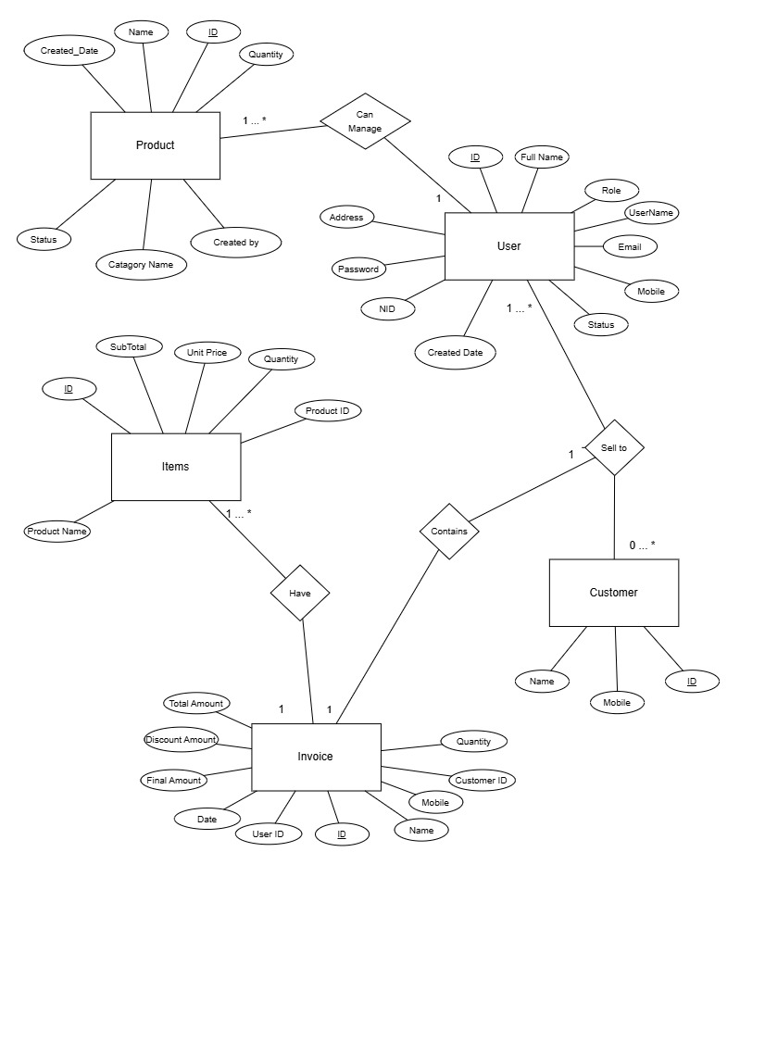

**Explanation of Entities and Relationships:**

## **UserInfo** (Stores user information)

* USER_ID (Primary Key)
* ROLE (Admin / Employee)
* FULL_NAME
* USERNAME (Unique)
* EMAIL (Unique)
* MOBILE (Unique)
* PASSWORD
* NID (Unique)
* ADDRESS
* CREATED_DATE
* STATUS (Active / Inactive)

## **CustomerInfo** (Stores customer details)

* CUSTOMER_ID (Primary Key)
* CUSTOMER_NAME
* CUSTOMER_MOBILE (Unique recommended)

## **ProductInfo** (Stores product and inventory details)

* PRODUCT_ID (Primary Key)
* PRODUCT_NAME
* QUANTITY (Stock)
* CATEGORY_NAME
* UNITPRICE
* CREATED_DATE
* IS_AVAILABLE
* CREATED_BY_USER_ID (Foreign Key)

**Invoice (Stores invoice billing details)**

* INVOICE_ID (Primary Key)
* USER_ID (Foreign Key)
* CUSTOMER_ID (Foreign Key)
* **CUSTOMER_NAME (**Stored for quick display**)**
* **CUSTOMER_MOBILE** (Stored for quick display)
* TOTAL_AMOUNT
* DISCOUNT_AMOUNT
* FINAL_AMOUNT
* INVOICE_DATE

**InvoiceItems (Stores invoice item details)**

* INVOICE_ITEM_ID (Primary Key)
* INVOICE_ID (Foreign Key)
* PRODUCT_ID (Foreign Key)
* PRODUCT_NAME
* QUANTITY
* UNIT_PRICE
* SUB_TOTAL

**Chapter: 03b – SQL Queries**

### ****1. Database Creation****

The database is created to store all information related to users, customers, products, invoices, and sales records.

**Database Name:** FarmInvoiceManager

This database serves as the central storage system for the entire application.

### ****2. Table Creation****

Several tables are created to define the structure of the database. These tables represent the core entities of the Farm Invoice Manager system, including:

* **UserInfo** – stores admin and employee information
* **CustomerInfo** – stores customer details
* **ProductInfo** – stores product information
* **InvoiceDetails** – stores invoice summary data
* **InvoiceItems** – stores item-wise invoice details

### ****3. Insert Queries (Create Operation)****

Insert queries are used to add new records into the database.  
Examples include:

* Adding new users (Admin / Employee)
* Adding customers
* Adding products
* Creating invoices and invoice items

### ****4. Select Queries (Read Operation)****

Select queries are used to retrieve data from the database for display and reporting purposes.  
They are used to:

* Show user lists
* Display customer information
* Load product lists
* Generate invoices
* View sales reports

### ****5. Update Queries (Update Operation)****

Update queries are used to modify existing records in the database.  
They are mainly used for:

* Updating user information
* Updating product details
* Resetting username or password
* Updating invoice or stock data

### ****6. Delete Queries (Delete Operation)****

Delete queries are used to remove unwanted or obsolete records from the database.  
Examples include:

* Deleting users
* Deleting products
* Deleting customers
* Deleting invoices and invoice items

CREATE TABLE [dbo].[UserInfo] (

[USER_ID] NVARCHAR(10) NOT NULL,

[ROLE] NVARCHAR(10) NOT NULL,

[FULL_NAME] NVARCHAR(50) NOT NULL,

[USERNAME] NVARCHAR(50) NOT NULL,

[EMAIL] NVARCHAR(50) NOT NULL,

[MOBILE] NVARCHAR(20) NOT NULL,

[PASSWORD] NVARCHAR(50) NOT NULL,

[NID] NVARCHAR(20) NOT NULL,

[ADDRESS] NVARCHAR(50) NOT NULL,

[CREATED_DATE] DATE NOT NULL,

[STATUS] BIT NOT NULL,

CONSTRAINT [PK_UserInfo] PRIMARY KEY CLUSTERED ([USER_ID] ASC)

);

CREATE TABLE dbo.CustomerInfo (

CUSTOMER_ID NVARCHAR(10) NOT NULL PRIMARY KEY,

CUSTOMER_NAME NVARCHAR(50) NOT NULL,

CUSTOMER_MOBILE NVARCHAR(20) NOT NULL

);

CREATE TABLE [dbo].[ProductInfo] (

[PRODUCT_ID] NVARCHAR(10) NOT NULL PRIMARY KEY,

[PRODUCT_NAME] NVARCHAR(50) NOT NULL,

[QUANTITY] INT NOT NULL,

[CATEGORY_NAME] NVARCHAR(50) NOT NULL,

[UNITPRICE] FLOAT NOT NULL,

[CREATED_DATE] DATE NOT NULL,

[IS_AVAILABLE] BIT NOT NULL,

[CREATED_BY_USER_ID] NVARCHAR(10) NOT NULL,

FOREIGN KEY ([CREATED_BY_USER_ID]) REFERENCES [dbo].[UserInfo]([USER_ID])

);

CREATE TABLE dbo.InvoiceItems (

INVOICE_ITEM_ID INT IDENTITY(1,1) PRIMARY KEY,

INVOICE_ID NVARCHAR(10) NOT NULL,

PRODUCT_ID NVARCHAR(10) NOT NULL,

PRODUCT_NAME NVARCHAR(100) NOT NULL,

QUANTITY INT NOT NULL,

UNIT_PRICE DECIMAL(10,2) NOT NULL,

SUB_TOTAL DECIMAL(10,2) NOT NULL,

CONSTRAINT FK_InvoiceItems_ProductInfo

FOREIGN KEY (PRODUCT_ID) REFERENCES dbo.ProductInfo(PRODUCT_ID)

);

CREATE TABLE dbo.InvoiceDetails (

INVOICE_ID NVARCHAR(10) NOT NULL PRIMARY KEY,

USER_ID NVARCHAR(10) NOT NULL,

CUSTOMER_ID NVARCHAR(10) NOT NULL,

CUSTOMER_NAME NVARCHAR(50) NOT NULL,

CUSTOMER_MOBILE NVARCHAR(20) NOT NULL,

TOTAL_AMOUNT DECIMAL(10,2) NOT NULL,

DISCOUNT_AMOUNT DECIMAL(10,2) NOT NULL,

FINAL_AMOUNT DECIMAL(10,2) NOT NULL,

INVOICE_DATE DATE NOT NULL,

FOREIGN KEY (USER_ID) REFERENCES dbo.UserInfo(USER_ID)

);

**FormLogin**

string query = $"SELECT USER_ID, FULL_NAME, ROLE, STATUS

FROM UserInfo

WHERE (USERNAME = '{username}' OR USER_ID = '{username}')

AND PASSWORD = '{password}'";

**FormAddCustomer**

SELECT MAX(CUSTOMER_ID) FROM CustomerInfo;

INSERT INTO CustomerInfo (CUSTOMER_ID, CUSTOMER_NAME, CUSTOMER_MOBILE)

VALUES ('{newCustomerId}', '{this.txtCustomerName.Text}', '{this.txtMobile.Text}');

**FormAddProduct**

SELECT ISNULL(MAX(CAST(SUBSTRING(PRODUCT_ID,5,10) AS INT)),0) FROM ProductInfo

INSERT INTO ProductInfo (PRODUCT_ID, PRODUCT_NAME, QUANTITY, CATEGORY_NAME, UNITPRICE, CREATED_DATE, IS_AVAILABLE, CREATED_BY_USER_ID)

VALUES (@ID, @NAME, @QTY, @CAT, @PRICE, @DATE, @STATUS, @CREATED_BY_USER_ID)

**FormAddSales**

SELECT UNITPRICE, QUANTITY FROM ProductInfo WHERE PRODUCT_ID = '{cmbProduct.SelectedValue}';

SELECT PRODUCT_ID, PRODUCT_NAME, UNITPRICE, QUANTITY, CREATED_DATE FROM ProductInfo WHERE PRODUCT_ID = '{productId}';

SELECT PRODUCT_ID, PRODUCT_NAME, IS_AVAILABLE FROM ProductInfo WHERE IS_AVAILABLE = 1;

SELECT CUSTOMER_ID, CUSTOMER_MOBILE FROM CustomerInfo;

SELECT CUSTOMER_NAME FROM CustomerInfo WHERE CUSTOMER_MOBILE = '{cmbNumber.Text.Trim()}';

INSERT INTO InvoiceDetails (INVOICE_ID, USER_ID, CUSTOMER_ID, CUSTOMER_NAME, CUSTOMER_MOBILE, TOTAL_AMOUNT, DISCOUNT_AMOUNT, FINAL_AMOUNT, INVOICE_DATE) VALUES (...)

INSERT INTO InvoiceItems (INVOICE_ID, PRODUCT_ID, PRODUCT_NAME, QUANTITY, UNIT_PRICE, SUB_TOTAL) VALUES (...)

UPDATE ProductInfo SET QUANTITY = QUANTITY - {soldQuantity} WHERE PRODUCT_ID = '{productID}';

**FormAddUser**

SELECT ISNULL(MAX(CAST(SUBSTRING(USER_ID,3,10) AS INT)),0) FROM UserInfo WHERE USER_ID LIKE '[AE]-%'

INSERT INTO dbo.UserInfo (USER_ID, ROLE, FULL_NAME, USERNAME, EMAIL, MOBILE, PASSWORD, NID, ADDRESS, CREATED_DATE, STATUS) VALUES (@USER_ID, @ROLE, @FULL_NAME, @USERNAME, @EMAIL, @MOBILE, @PASSWORD, @NID, @ADDRESS, CAST(GETDATE() AS DATE), @STATUS)

**FormAdminView**

SELECT * FROM UserInfo;

SELECT * FROM CustomerInfo;

DELETE FROM UserInfo WHERE USER_ID = 'userId';

SELECT * FROM UserInfo WHERE FULL_NAME LIKE '%searchText%' OR USERNAME LIKE '%searchText%' OR USER_ID LIKE '%searchText%' ORDER BY USER_ID;

SELECT * FROM UserInfo WHERE USER_ID = 'adminUserID';

DELETE FROM CustomerInfo WHERE CUSTOMER_ID = 'customerId';

SELECT * FROM CustomerInfo WHERE CUSTOMER_MOBILE LIKE '%searchText%' ORDER BY CUSTOMER_ID;

**FormEditUser**

SELECT *

FROM UserInfo

WHERE USER_ID = '{UserId}';

UPDATE UserInfo SET

FULL_NAME = '{fullName}',

EMAIL = '{email}',

USERNAME = '{username}',

PASSWORD = '{password}',

MOBILE = '{mobile}',

NID = '{nid}',

ADDRESS = '{address}',

ROLE = '{role}',

STATUS = {status}

WHERE USER_ID = '{UserId}';

**FormEmployee**

SELECT *

FROM UserInfo

WHERE USER_ID = '{UserID}';

SELECT *

FROM CustomerInfo;

SELECT *

FROM CustomerInfo

WHERE CUSTOMER_MOBILE LIKE '%{searchText}%'

ORDER BY CUSTOMER_ID;

**FormFindPassword**

SELECT PASSWORD

FROM UserInfo

WHERE USER_ID = '{userId}'

AND USERNAME = '{username}'

AND MOBILE = '{mobile}';

**FormInvoicePrint**

SELECT CUSTOMER_NAME, CUSTOMER_MOBILE,

TOTAL_AMOUNT, DISCOUNT_AMOUNT, FINAL_AMOUNT, INVOICE_DATE

FROM InvoiceDetails

WHERE INVOICE_ID = '{InvoiceID}';

SELECT P.PRODUCT_NAME, I.QUANTITY, I.UNIT_PRICE, I.SUB_TOTAL

FROM InvoiceItems I

INNER JOIN ProductInfo P ON I.PRODUCT_ID = P.PRODUCT_ID

WHERE I.INVOICE_ID = '{InvoiceID}';

**FormManageProducts**

SELECT *

FROM ProductInfo;

SELECT *

FROM ProductInfo

WHERE PRODUCT_NAME LIKE '%{searchText}%'

OR PRODUCT_ID LIKE '%{searchText}%'

ORDER BY PRODUCT_ID;

DELETE

FROM ProductInfo

WHERE PRODUCT_ID = '{productId}';

**FormReset**

SELECT USERNAME, PASSWORD

FROM UserInfo

WHERE USER_ID = '{UserId}';

UPDATE UserInfo

SET USERNAME = '{newUserName}', PASSWORD = '{newPassword}'

WHERE USERNAME = '{currentUsername}' AND PASSWORD = '{currentPassword}';

**FormUpdateProduct**

SELECT *

FROM ProductInfo

WHERE PRODUCT_ID = @ID;

UPDATE ProductInfo

SET PRODUCT_NAME = @NAME,

QUANTITY = @QTY,

CATEGORY_NAME = @CAT,

UNITPRICE = @PRICE,

CREATED_DATE = @DATE,

IS_AVAILABLE = @STATUS

WHERE PRODUCT_ID = @ID;

**FromSalesReport**

SELECT * FROM InvoiceDetails;

SELECT INVOICE_DATE, SUM(CAST(FINAL_AMOUNT AS float)) AS TotalSales

FROM InvoiceDetails

GROUP BY INVOICE_DATE

ORDER BY INVOICE_DATE;

SELECT INVOICE_DATE, SUM(CAST(FINAL_AMOUNT AS float)) AS TotalSales

FROM InvoiceDetails

WHERE INVOICE_DATE >= '{fromDate}'

AND INVOICE_DATE <= '{toDate}'

GROUP BY INVOICE_DATE

ORDER BY INVOICE_DATE;

SELECT *

FROM InvoiceDetails

WHERE INVOICE_DATE >= '{fromDate}'

AND INVOICE_DATE <= '{toDate}'

ORDER BY INVOICE_DATE;

SELECT PRODUCT_ID, PRODUCT_NAME, QUANTITY, UNIT_PRICE, SUB_TOTAL

FROM InvoiceItems

WHERE INVOICE_ID = '{invoiceId}';

SELECT *

FROM InvoiceDetails

WHERE CUSTOMER_MOBILE LIKE '%{mobile}%'

ORDER BY INVOICE_DATE;

DELETE FROM InvoiceItems

WHERE INVOICE_ID = '{invoiceId}';

DELETE FROM InvoiceDetails

WHERE INVOICE_ID = '{invoiceId}';

**Chapter 04: Screenshots**

**Form Name:** Login Form  
**Purpose:** User authentication (Admin / Employee)

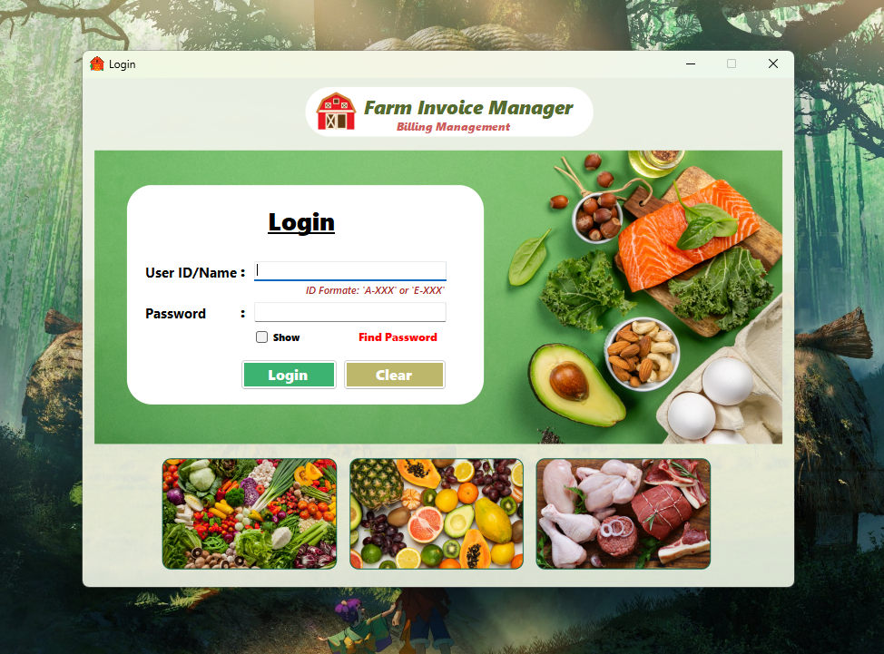

**Form Name:** Find Password

**Purpose:** Recover login credentials

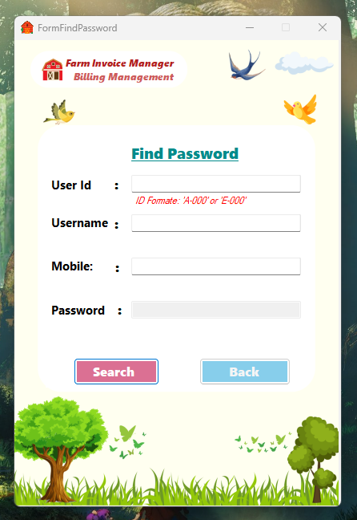

**Form Name:** Admin Dashboard  
**Purpose:** Admin main control pane

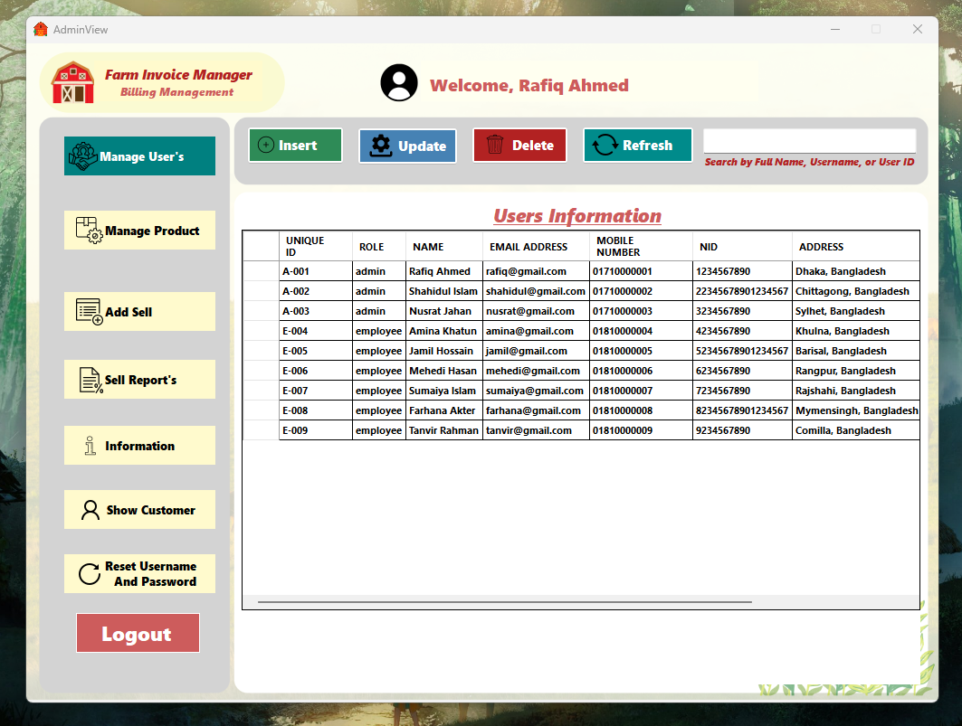

**Form Name:** Employee Dashboard  
**Purpose:** Employee main control panel

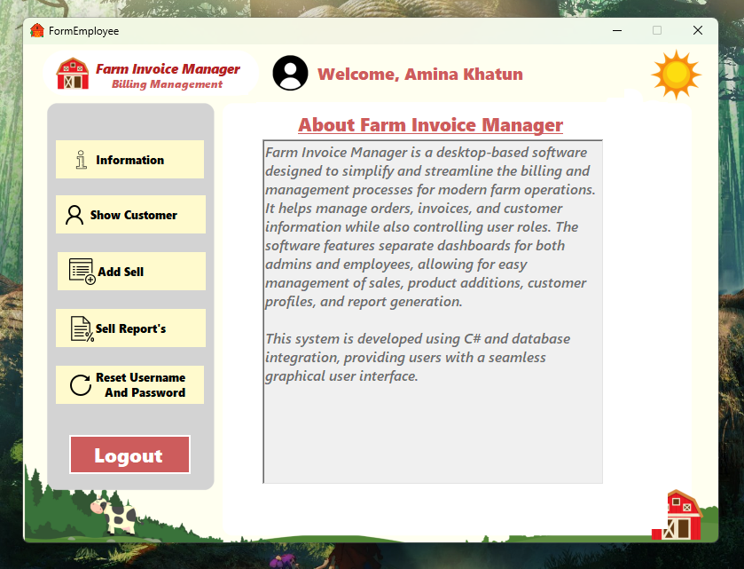

**Form Name:** Reset Password Form  
**Purpose:** Recover login credentials

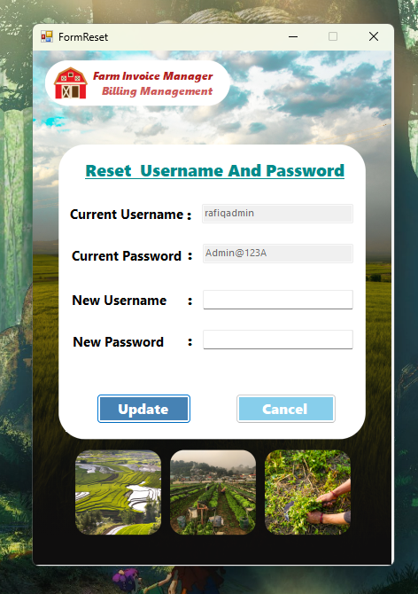

**Form Name:** Add New User Form  
**Purpose:** Create admin or employee account

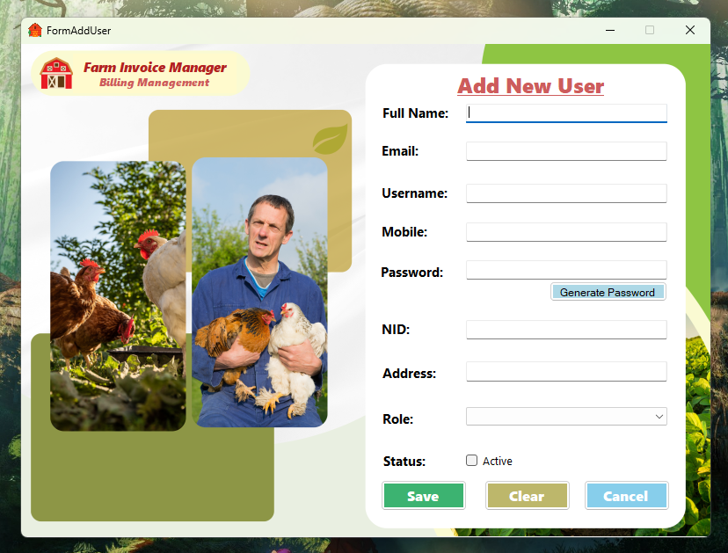

**Form Name:** Edit Existing User Form  
**Purpose:** Update user information

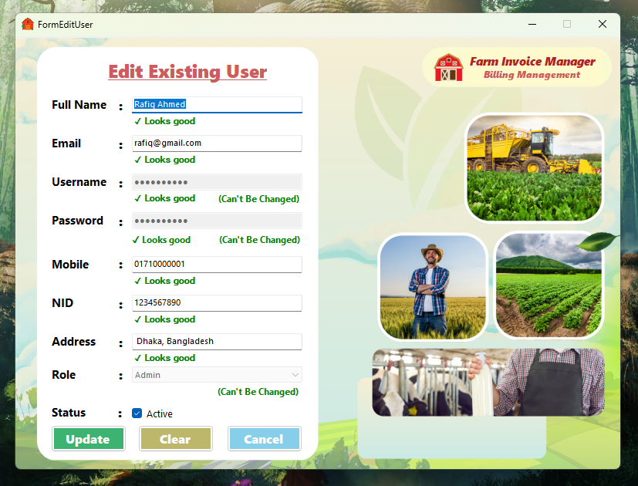

**Form Name:** Manage Products Form  
**Purpose:** View, update, delete products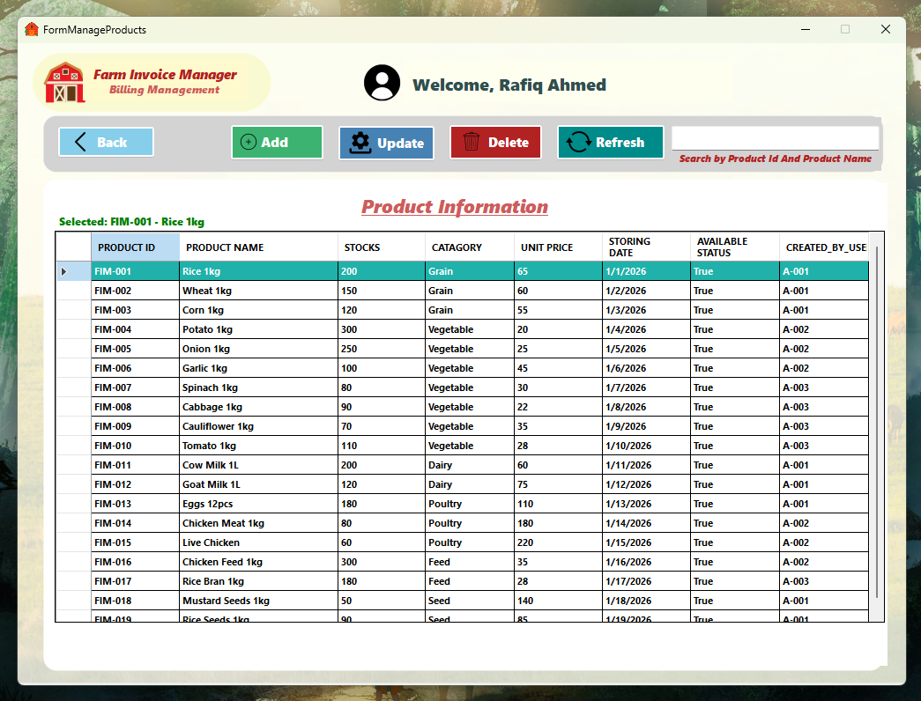

**Form Name:** Add Product Form  
**Purpose:** Add new product information.

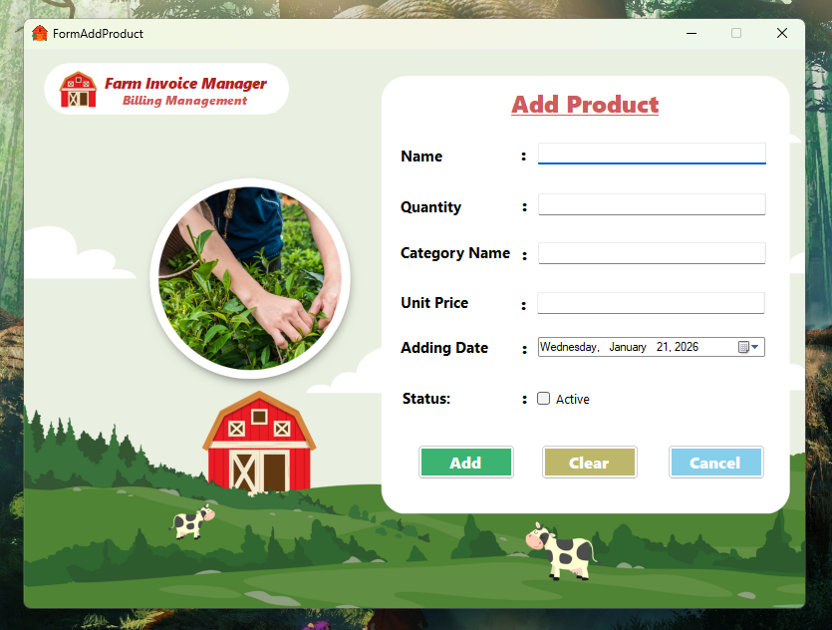

**Form Name:** Update Product Form  
**Purpose:** Update existing product details.

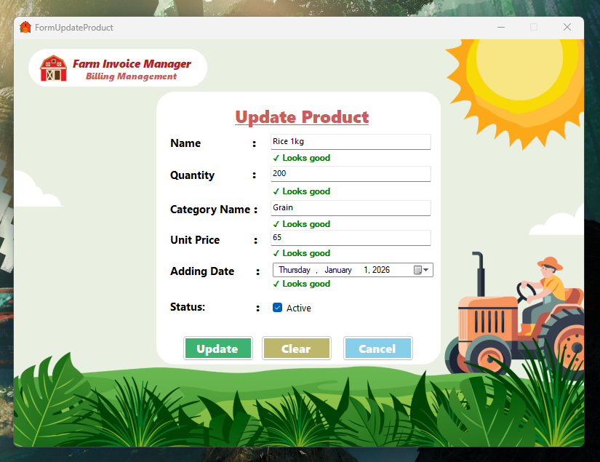

**Form Name:** Personal Information Form  
**Purpose:** View logged-in user details.

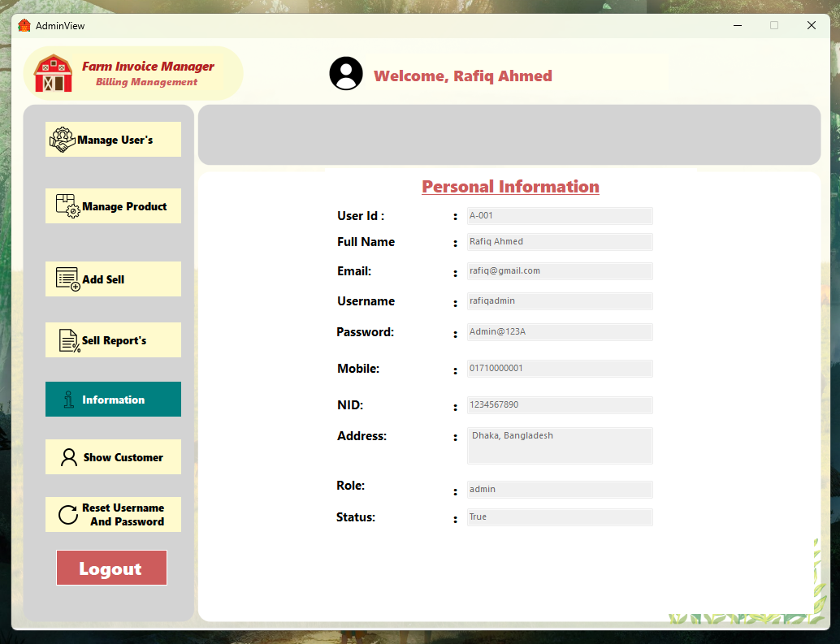

**Form Name:** Show Customer Form  
**Purpose:** View premium customer list.

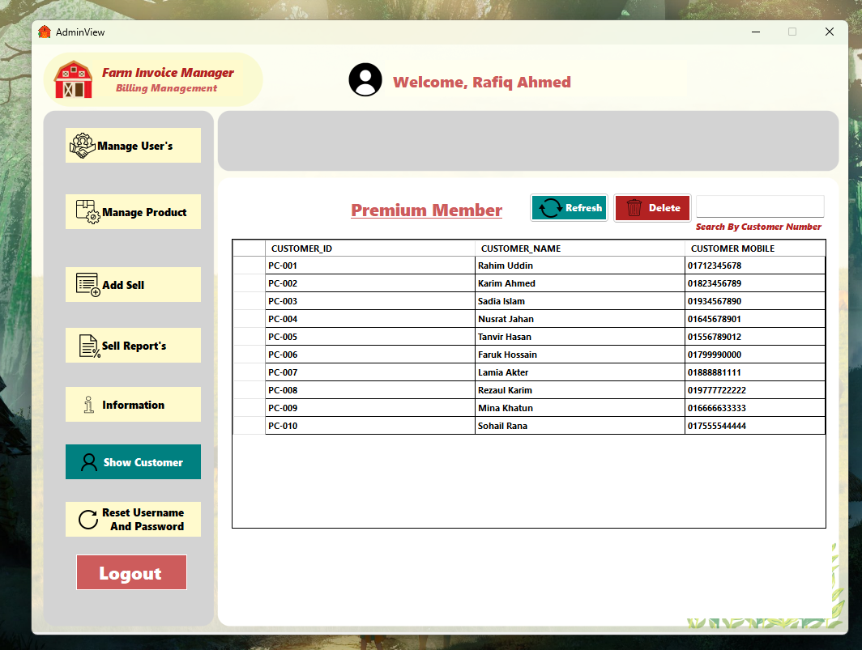

**Form Name:** Personal Information Form (Employee)  
**Purpose:** View logged-in employee details.

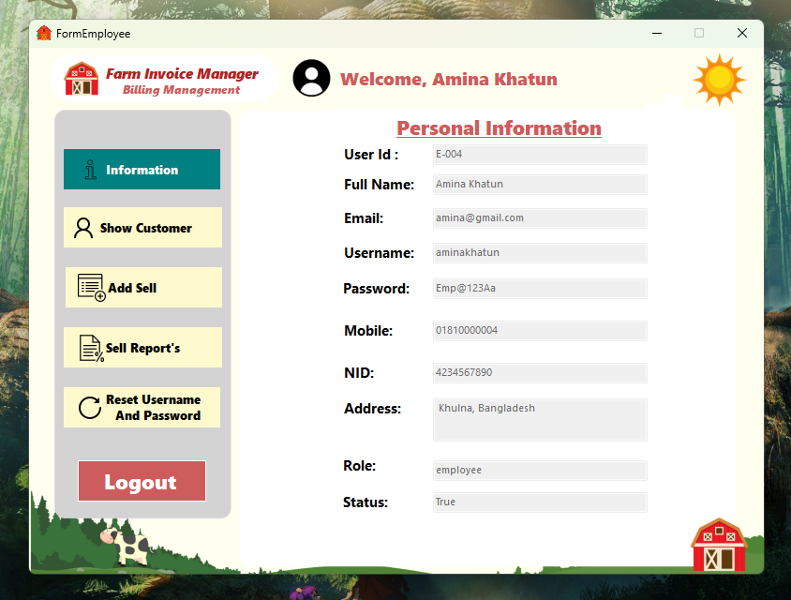

**Form Name:** Show Customer Form (Employee)  
**Purpose:** View premium customer list.

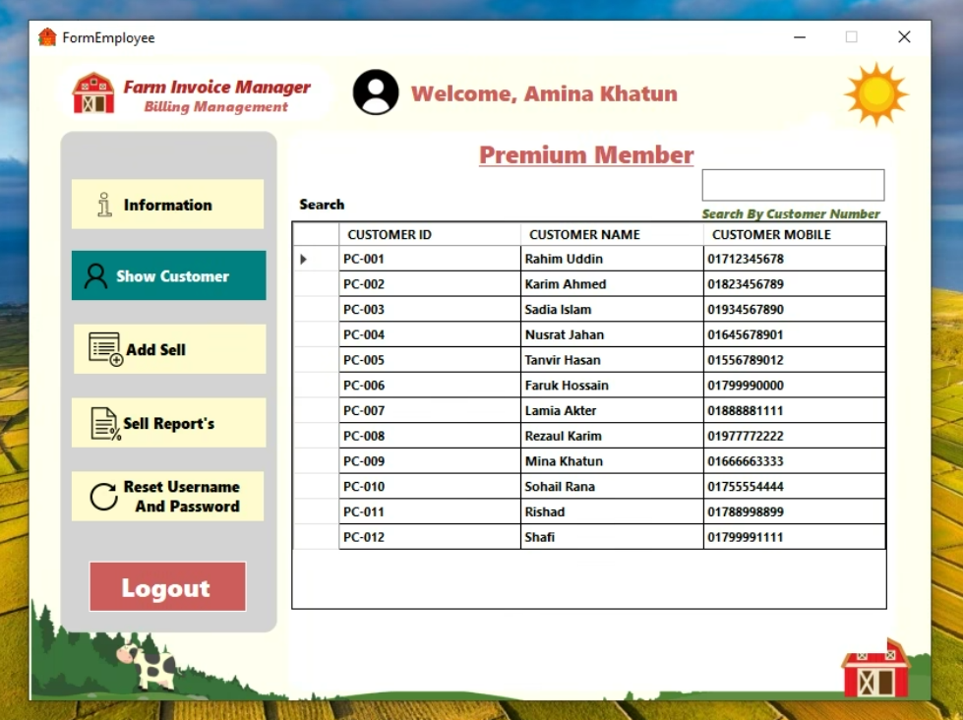

**Form Name:** Add Customer Form  
**Purpose:** Add new customer information

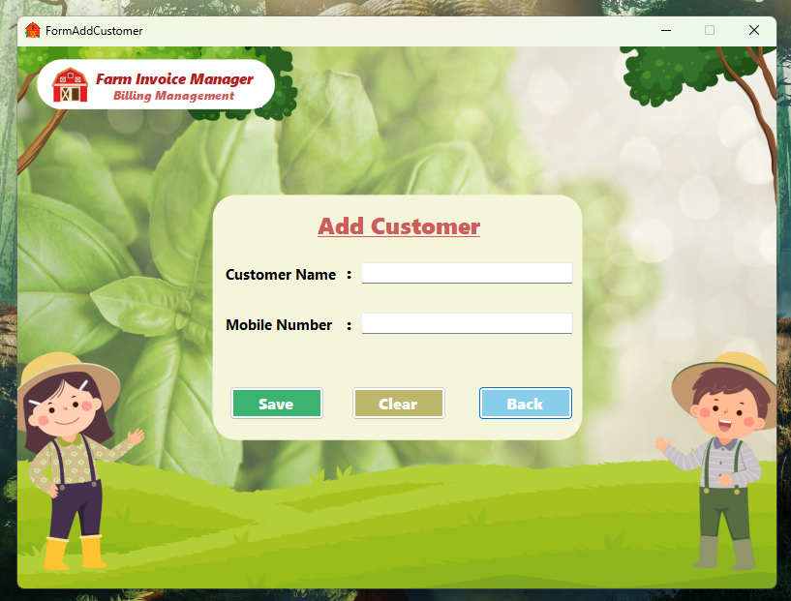

**Form Name:** Add Sales Form  
**Purpose:** Create and manage customer sales invoices.

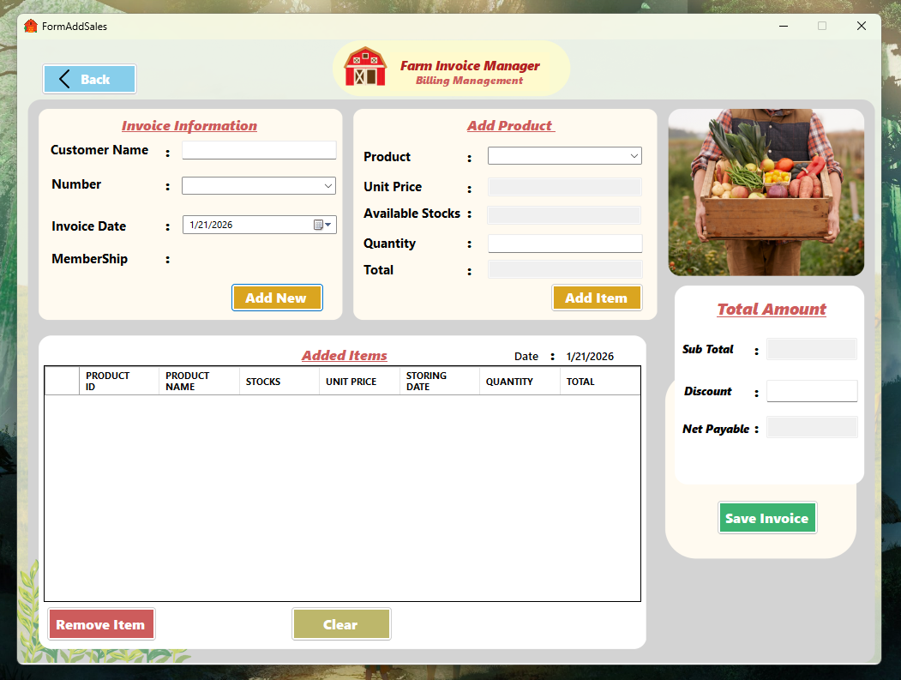

**Form Name:** Sales Report Form  
**Purpose:** View and analyze date-wise sales information.

